The Impact Entrepreneurship has on Individual Happiness

Contents
Section 1: Introduction 1
Section 2: Economic theory 1
Section 3: Job satisfaction 3
Section 4: Life satisfaction 5
Section 5: Conclusion 8
References: 9

Section 1: Introduction

With UK labour productivity currently in crisis (Partington, 2019), it is increasingly important to understand worker motivation and encourage innovation, one source of which is entrepreneurship. Whilst undertaking my placement at a startup, I worked alongside various entrepreneurs within a co-working office. This made me reflect on the impact entrepreneurship has on life satisfaction; happiness economics is an emerging field which concerns the factors that affect individual happiness. Entrepreneurs may enjoy the high independence of their role, yet they also face longer working hours with a lower salary, so the overall impact of entrepreneurship on happiness is unclear. In Section 2 I outline relevant economic theory regarding the topic; in Section 3 I compare job satisfaction between entrepreneurs and employees; in Section 4 I evaluate the impact of job satisfaction upon life satisfaction, and in Section 5 I present a discussion of the results. I conclude that entrepreneurs obtain greater job satisfaction than employees, yet their overall life satisfaction is not improved due to low leisure satisfaction. Yet these results may be skewed due to heterogeneity between entrepreneurs.

Section 2: Economic theory

Within economics, the concept of ‘utility’ is typically used to encompass happiness or welfare (Lane, 2017). In a simple utility function, utility U increases with consumption C and leisure time L (Borjas, 2016), hence focusing on material outcomes:

$U=f(C,L)$ (1)

This implies that individuals prefer jobs that give them an optimal allocation of consumption and leisure time. A less traditional view is that utility can also be gained from the conditions and process associated with outcomes, such as interpersonal relationships and low hierarchy (Frey et al, 2004). This is known as procedural utility. Entrepreneurism typically involves less leisure time and consumption, implying lower utility from material outcomes, yet greater independence, which signals high procedural utility. To determine the impact of entrepreneurism on overall life satisfaction, it is therefore necessary to evaluate the trade-off between these two elements of utility. It should be noted that ‘satisfaction’, ‘happiness’, ‘welfare’ and ‘utility’ are henceforth used as synonyms within this essay as a simplification.

Happiness economists use a self-reported measure $r$ to examine happiness:

$r=h\left(u\left(y,z,t\right)\right)+e$ (2)

Where $h(…)$ is a function relating actual to reported well-being, $u(…)$ is ‘true’ happiness, $y$ is income, $z$ contains personal characteristics and $t$ is time period (Blanchflower and Oswald, 2004). The importance of procedural elements can also be incorporated in the function (2) by including a further parameter $p$ :

$r=h\left(u\left(y,z,t,p\right)\right)+e$ (3)

Happiness economics therefore considers more factors than a simple utility function, including personal and demographic variables. However, individuals have an imperfect ability to report their happiness accurately, which is contained in the error term $e$. As portrayed in Figure 1, $h$ rises in steps as $u$ increases because individuals aren’t able to accurately relay their level of well-being (Blanchflower and Oswald, 2004). Although this is a methodological problem within happiness economics, $r$ is generally viewed as an accurate measure since it is stable across nations and individuals (Di Tella et al, 2003) and correlated with many other relevant indicators (Lane, 2017). In the rest of the essay, these theoretical underpinnings will be used to compare the happiness of entrepreneurs and employees.
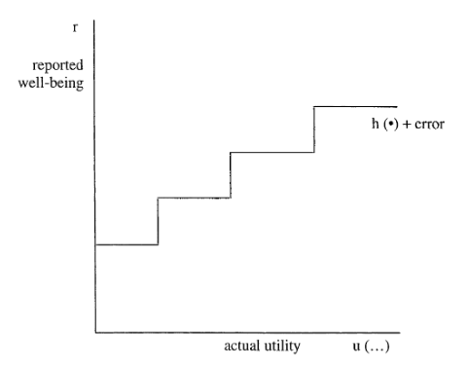

Figure 1: the relationship between reported well-being and actual utility (taken from Blanchflower and Oswald, 2004)

Section 3: Job satisfaction

Despite working longer hours and earning less income, the self-employed are less likely than employees to find their job mentally straining (Andersson, 2008). Contrary to the predictions of the standard utility function, this implies entrepreneurs experience greater work satisfaction (in most studies self-employment is used as a proxy for entrepreneurship). Even when personality characteristics are accounted for using a happiness economics approach, discrepancy in material outcomes like income and working hours don’t fully explain the differences in work satisfaction between the two groups (Benz and Frey, 2004; Benz and Frey, 2006). Procedural utility may explain these differences, but isn’t tested for explicitly. Usually, a generic measure of job satisfaction is used, which may be interpreted differently by different people. Furthermore, most analysis has focused on a small number of European countries (Andersson, 2008; Benz and Frey, 2004).

Millán et al (2011) overcame these deficiencies by studying 15 European nations – thus accounting for heterogeneity between countries – and asking participants to rate their satisfaction with the ‘type of work’ and ‘job security’ separately to avoid different interpretations of ‘job satisfaction’. As ‘type of work’ focuses on processes rather than outcomes, procedural utility is also surveyed explicitly. The raw data, shown in Table 1, demonstrates the percentages of workers that rated their job satisfaction at the highest level. Although in general the self-employed are more satisfied with the type of work and less satisfied with job security, all countries are not homogeneous. For example, there is an 85% difference between satisfaction with type of work amongst the self-employed in Germany compared with those from Portugal. This discrepancy proves the importance of studying various countries.
Table 1: percentages of different groups of employees that are highly satisfied with different aspects of their work (results taken from Millán et al, 2011).
Country | All workers | Paid employees | Self-employed
Satisfaction with type of work
Germany | 59.74 | 57.39 | 78.25
UK | 60.21 | 56.78 | 66.07
Portugal | 30.08 | 29.56 | 31.32
Unweighted average | 58.19 | 56.38 | 65.58
Satisfaction with job security
Germany | 48.06 | 47.62 | 51.5
UK | 44.97 | 46.39 | 42.56
Portugal | 23.88 | 23.09 | 25.76
Unweighted average | 49.57 | 50.08 | 47.34

An ordered logit model, which is appropriate for a categorical dependent variable, was then used to further examine the differences between self-employed and paid employed workers. After estimating predicted probabilities, it was found that the coefficient on type of work was highly statistically significant for the self-employed, who are 14% more likely to be satisfied with the type of work (Millán et al, 2011). This suggests that procedural utility is a driver of job satisfaction, which has consistently been found to be higher amongst the self-employed. However, the self-employed are 9% less likely to be satisfied with their job security; it is possible that entrepreneurs put less weight on job security relative to paid employees, contributing to greater job satisfaction overall. During my placement I noticed that the co-founders of the business seemed calm, happy and passionate about their work, despite working long hours and confronting the possibility of the business failing. This suggests that they valued processes over outcomes and job security. However, those in supervisory or non-intermediate jobs have higher work satisfaction than average employees (Millán et al, 2011); entrepreneurship is not the only way to increase job satisfaction.

Section 4: Life satisfaction

The impact of greater job satisfaction on life satisfaction remains unclear. Figure 2 portrays a two-layer model of happiness for person x, in which various types of satisfaction including work satisfaction contribute to general satisfaction. Yet two types of satisfaction may influence each other or exert opposing effects, such as leisure satisfaction and work satisfaction, as suggested by the discussion of procedural and material elements of utility in Section 2.

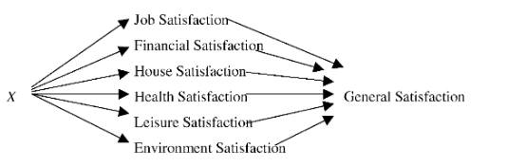

Figure 2: the two-layer model of happiness (taken from van Praag et al, 2003)

In contrast to the job satisfaction literature, studies that focus on the link between entrepreneurship and life satisfaction have yielded inconsistent results. There is some evidence that although the self-employed report feeling more pressure and stress, they are highly satisfied with their life (Blanchflower and Oswald, 1998; Blanchflower, 2004). This suggests that the positive aspects of job satisfaction counterbalance negative factors. Furthermore, Carree and Verheul (2011) found that intrinsic motivation enhances satisfaction with psychological well-being, suggesting that procedural utility increases overall life satisfaction. However, both studies fail to make a direct comparison between entrepreneurs and employees. Binder and Coad (2013) tackled this by comparing the life satisfaction of those who moved from paid employment into self-employment (and vice versa) with a counterfactual constructed using matching estimators to represent a similar group that didn’t move. They also distinguished between opportunity entrepreneurs, who become entrepreneurs from choice, and necessity entrepreneurs, who had no other options. They found that although self-employment had no impact on life satisfaction for necessity entrepreneurs, it had a positive effect amongst opportunity entrepreneurs, when both groups were compared to the counterfactual (Binder and Coad, 2013). This highlights the importance of heterogeneity between entrepreneurs, and it is implied that those who self-select into entrepreneurship (opportunity entrepreneurs) may be able to derive more utility from their self-employment. However, individuals were only examined over a short time period when they first switched.

In contrast, van der Zwan et al (2018) examined individual satisfaction at various points in time after a switch was made from self-employment to paid employment or vice versa. Groups were compared with a baseline group of non-switchers instead of a counterfactual: this makes causality more difficult to determine, but the persistence of the impact switching has upon happiness could be examined. A persistent impact implies that the individual was made permanently better off by switching, which creates a more complete depiction than previous studies. Life, work and leisure satisfaction were all examined, so the trade-off between leisure and work satisfaction and their impact on general life satisfaction could also be examined explicitly.

Figure 3 portrays the fixed effects coefficients on life satisfaction for each period following the switch into either self-employment or paid employment. In the year the switch takes place $t$ and the following year $t+1$, only moving into self-employment increases life satisfaction. However, by the period $t+2$, those who switch into paid employment have a more positive trend line. This suggests that although there is an initial benefit from switching into self-employment, the effect is not persistent, thus implying that increased job satisfaction from self-employment does not compensate for losses in other areas of satisfaction. The results from the fixed effects regression also indicate that the coefficients on life satisfaction for each year following the transition into self-employment were all statistically insignificant (van der Zwan et al, 2018). This verifies that becoming self-employed does not impact life satisfaction. As is suggested by the graph, there were more statistically significant regression results for switching into paid employment. However, it can be seen from Figure 3 that none of the coefficients differ substantially from zero, which implies that switching has minimal impact on life satisfaction. Furthermore, there is significant overlap between the two groups in the grey shaded area representing the standard deviations, which also suggests there aren’t meaningful differences between the two groups.

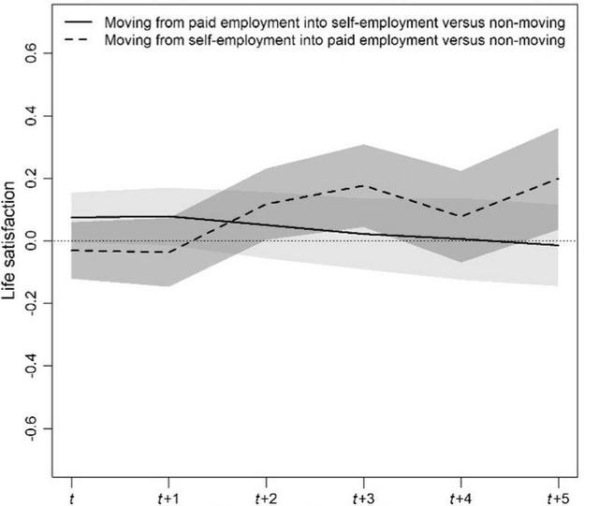

Figure 3: fixed effects coefficients for life satisfaction after moving into self-employment and paid employment versus non-moving (taken from van der Zwan et al, 2018)

The mechanisms behind this result must be examined. The coefficients on work and leisure satisfaction were found to be highly significant, but to work in opposite directions. As expected, switching to self-employment has a negative impact on leisure satisfaction but a positive effect on work satisfaction. However, the impact of self-employment on work satisfaction ceases to be positive and significant by the period $t+5$, whereas its negative impact on leisure satisfaction is persistent. The opposing forces of leisure and work satisfaction thus explain why employment type does not impact life satisfaction overall. It is also implied that for the long-term self-employed, decreased leisure satisfaction may outweigh the initially positive effect of job satisfaction, which decreases over time as individuals adapt to their new environment (van der Zwan et al, 2018). This contrasts with my own observations during my placement, as the founders of the business appeared happier in general than most of the other employees, although they were at period $t+3$ of self-employment.

However, there are some potential problems with the results. Self-employment is generally used as a proxy for entrepreneurship, which is problematic because ‘self-employed’ encompasses many different groups (Benz and Frey, 2008; Blanchflower, 2000). Binder and Coad (2013) prove that there is heterogeneity between necessity and opportunity entrepreneurs and the latter derive more utility from self-employment. Furthermore, entrepreneurs that create their own startups – such as those I encountered – are very different to self-employed tradespeople, for example. Therefore, although on average self-employment has a negative effect on life satisfaction due to a persistent negative impact on leisure satisfaction, a certain group of opportunity entrepreneurs may be affected differently. They may weight aspects of their happiness differently or be less affected by the negative outcomes, for instance by handling stress better (Andersson, 2008).

Section 5: Conclusion

In conclusion, job satisfaction is greater amongst entrepreneurs due to the greater procedural utility they derive from their work, but on average this fails to increase overall life satisfaction. Multiple studies have demonstrated that entrepreneurs experience greater work satisfaction, but it appears that the negative and persistent decrease in leisure satisfaction counteracts the positive but temporary increase job satisfaction. Although there is some evidence of entrepreneurs being highly satisfied with their life, it is proven that switching from paid employment into self-employment does not impact life satisfaction in the long run. However, most methodologies fail to differentiate between different types of entrepreneurs and instead examine the self-employed as one homogeneous group. This could explain why the entrepreneurs I encountered during my placement, who consciously chose to pursue their career, appeared to be highly satisfied but this isn’t reflected in the results. People value procedural utility and material outcomes differently, and some individuals may also handle pressure and stress in distinct ways. Therefore, government policy should be cautious about encouraging too much entrepreneurship as a way to improve labour productivity growth, as it is not an appropriate choice for everyone. However, employees can be granted greater independence within their own role, which may increase job satisfaction and thus innovation.

References:

Andersson, P. (2008) ‘Happiness and health: Well-being among the self-employed.’ Journal of Socio-economics, 37(1), pp. 213-236.
Borjas, J.G. (2016) Labor economics. 7th edn. Boston, MA: McGraw-Hill.
Benz, M. and Frey, B.S. (2006) ‘Being Independent is a Great Thing: Subjective Evaluations of Self‐Employment and Hierarchy.’ Economica, 75(298), pp. 362-383.
Benz, M. and Frey, B.S. (2008) ‘The value of doing what you like: Evidence from the self-employed in 23 countries.’ Journal of Economic Behavior and Organization, 68(3), pp. 445-455.
Benz, M., Frey, B. and Lindh, T. (2004) ‘Being independent raises happiness at work.’ Swedish economic policy review, 11(2), pp. 95-138.
Binder, M. and Coad, A. (2003) ‘Life satisfaction and self-employment: a matching approach.’ Small Business Economics, 40(4), pp. 1009-1033.
Blanchflower, D.G. and Oswald, A.J. (2004) ‘Well-being over time in Britain and the USA.’ Journal of Public Economics, 88(7), pp. 1359-1386.
Blanchflower, D.G. and Oswald, A.J. (1998) ‘What Makes an Entrepreneur?’ Journal of Labor Economics, 16(1), pp. 26-60.
Blanchflower, D. and Henrekson, M. (2004) ‘Self-employment: more may not be better.’ Swedish economic policy review, 11(2), pp. 15-93.
Carree, M. and Verheul, I. (2011) ‘What Makes Entrepreneurs Happy? Determinants of Satisfaction Among Founders.’ Journal of Happiness Studies, 13(2), pp. 371-387.
Di Tella, R., MacCulloch, R.J and Oswald, A.J. (2006) ‘The Macroeconomics of Happiness.’ The Review of Economics & Statistics, 85(4), pp.809-827.
Lane, T., (2017) ‘How does happiness relate to economic behaviour? A review of the literature.’ Journal of Behavioral and Experimental Economics, 68, pp. 62-78.
Lange, T. (2009) ‘Job satisfaction and self-employment: autonomy or personality?’ Small Business Economics, 38(2), pp. 165-177.
Millán, J.M., Hessels, J., Thurik, R. and Aguado, R. (2011) ‘Determinants of job satisfaction: a European comparison of self-employed and paid employees.’ Small Business Economics, 40, pp.651-670.
Partington, R. UK worker productivity growth falls to two-year low on back of Brexit concerns. Available at: https://www.theguardian.com/business/2019/jan/09/uk-worker-productivity-falls-to-two-year-low-on-back-of-brexit-concerns (Accessed: 19 March 2019)
Praag, B.M.S., Frijters, P. and Ferrer-I-Carbonell, A., 2003. The anatomy of subjective well-being. Fa, 51(1), pp. 29-49.
Van Der Zwan, P., Hessels, J. and Rietveld, C.A. (2018) ‘Self-employment and satisfaction with life, work, and leisure.’ Journal of Economic Psychology, 64, pp.73-88.

